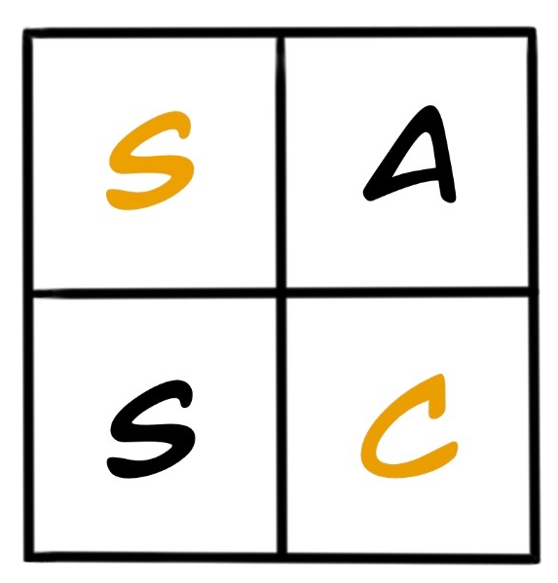

Stockbridge Area Senior Center
August 2026 Calendar
Hours: Tuesday - Thursday, 9:00am to 2:00pm Phone: (517) 480-0353

Now offering Open Craft Time in the Community Bay

GAME NIGHT
WEDNESDAY AUGUST 19TH
6:00-8:00PM

4 Tuesday  9:00am - Coffee & Chat  10:00am - Tai Chi-Cancelled  10:00am - Sweatin’ to the Oldies  11:00am - Chair Fit  12:00pm - Lunch  ROAST TURKEY  1:00pm - BINGO | 5 Wednesday  9:00am - Coffee & Chat  10:00am - Yoga with Diane  11:00am - Aging Matters Video Veterans Connection  12:00pm - Lunch  PORK CHOP  1:00pm - BINGO  1:00pm - Crafts in the Bay | 6 Thursday  9:00am - Coffee & Chat  9:30am - CADL Trivia  10:00am - Cardio Drumming  11:00am - Art For Your Mind  12:00pm - Lunch  CREOLE COD  12:30pm - Manicures with Shirley & Jennifer  1:00pm - BINGO
11 Tuesday  9:00am - Coffee & Chat  10:00am - Tai Chi  10:00am - Sweatin’ to the Oldies  11:00am - Chair Fit  12:00pm - Lunch  BEEF TACO  1:00pm - BINGO | 12 Wednesday  9:00am - Coffee & Chat  9:30am - Ascendant Foot Care $45  10:00am - Yoga with Diane  11:00am -Aging Matters Video Aging with Honor Veterans  12:00pm - Lunch  HAMBURGER  1:00pm - BINGO | 13 Thursday  9:00am - Coffee & Chat  10:00am - Cardio Drumming  11:00am - Jewelry with Christine $7.00-$15.00  12:00pm - Lunch  CHEESE RAVIOLI  12:30pm - Manicures with Shirley & Jennifer  1:00pm - BINGO
18 Tuesday  9:00am - Coffee & Chat  9:30am - Blood Pressure Check with Angie Adiska  10:00am - Tai Chi  10:00am - Sweatin’ to the Oldies  11:00am - Chair Fit  12:00pm - Lunch  MANICOTTI  1:00pm - BINGO | 19 Wednesday  9:00am - Coffee & Chat  10:00am - Yoga with Diane  11:00am - Paul Schwimmer Armed Forces Presentation  12:00pm - Lunch  SHEPHERD’S PIE  1:00pm - BINGO  1:00pm - Crafts  In the Bay  Game Night 6-8pm | 20 Thursday  9:00am - Coffee & Chat  9:30am - CADL Trivia  10:00am - Cardio Drumming  11:00am - Jack Faulk Music🎸  12:00pm - Lunch  CHICKEN STIR FRY  12:30pm - Manicures with Shirley & Jennifer  1:00pm - BINGO
25 Tuesday  9:00am - Coffee & Chat  10:00am - Tai Chi  10:00am - Sweatin’ to the Oldies  11:00am - Chair Fit  12:00pm - Lunch  BAKED HAM  1:00pm - GROCERY STORE BINGO 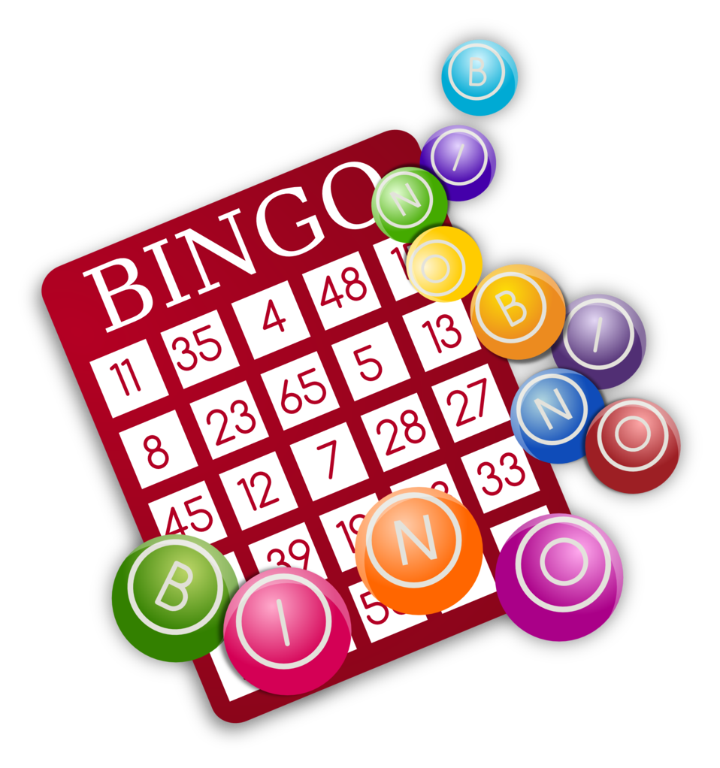 | 26 Wednesday  9:00am - Coffee & Chat  10:00am - Yoga with Diane  11:00am - Synergy Home Care Fall Prevention  12:00pm - Lunch  SLOPPY JOE ON BUN  1:00pm - BINGO  BOARD MEETING 3:30 PM  PUBLIC WELCOME | 27 Thursday  9:00am - Coffee & Chat  9:30am - CADL Trivia  10:00am - Cardio Drumming  11:00am - Behavioral Health  12:00pm - Lunch  PORK ROAST  12:30pm - Manicures with Shirley & Jennifer  1:00pm - BINGO
 | We are on a Mission for LONG TERM SUSTAINABILITY. Please consider donating to help enrich lives. Phone: (517) 480-0353, Email: sasc49285@gmail.com for more info, or mail to SASC PO Box 511 Stockbridge, MI 49285 | Coming Soon cold lunches on Mondays and Fridays . . . Keep your eyes and ears open for more info to come